
The primary analysis aims to evaluate the overall business performance across different cities by examining key operational, financial, and customer-related metrics.
Top and Bottom Performing Cities

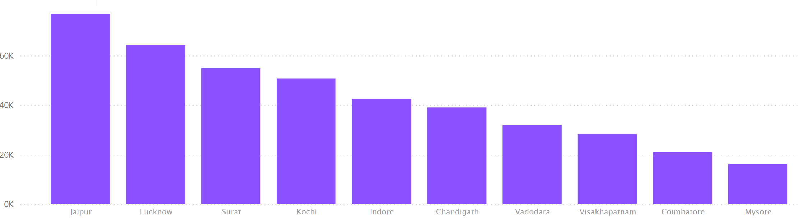
Top 3 Cities:
- Jaipur
- Lucknow
- Surat

Bottom 3 Cities:
- Vishakhapatnam
- Coimbatore
- Mysore

Average Fare per Trip by City

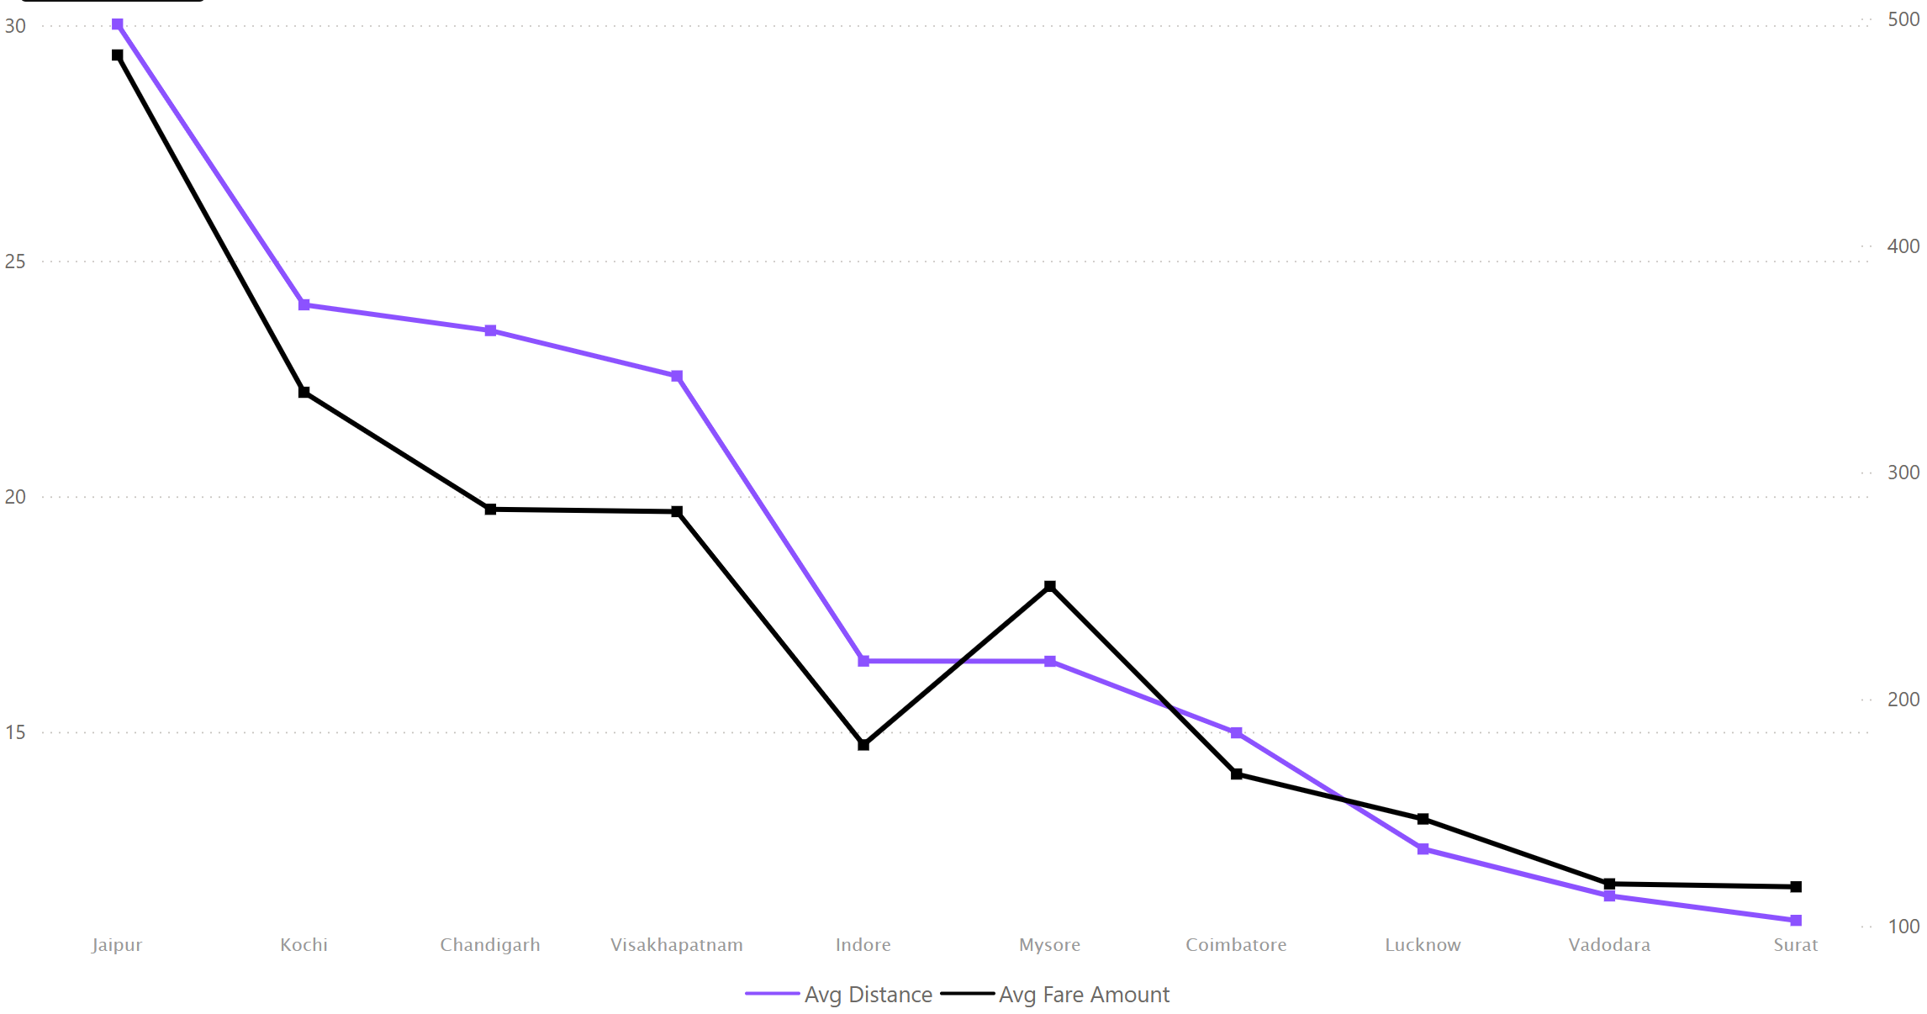

- Jaipur records both the highest average trip distance and the highest average fare, suggesting that longer trips may be contributing to higher fares.
- Kochi ranks second in average fare per trip at approximately ₹335, accompanied by an average trip distance of around 24 km, making it one of the higher-value markets in terms of trip revenue.
- Although Kochi and Chandigarh have nearly identical average trip distances, Kochi generates substantially higher average fare per trip. This suggests that factors beyond distance may be influencing fare generation across cities.
- Despite similar trip distances, Mysore's average fare is much higher, this deserves investigation.
Why are riders in Mysore paying significantly more for trips of similar length?

Average Ratings by City and Passenger Type

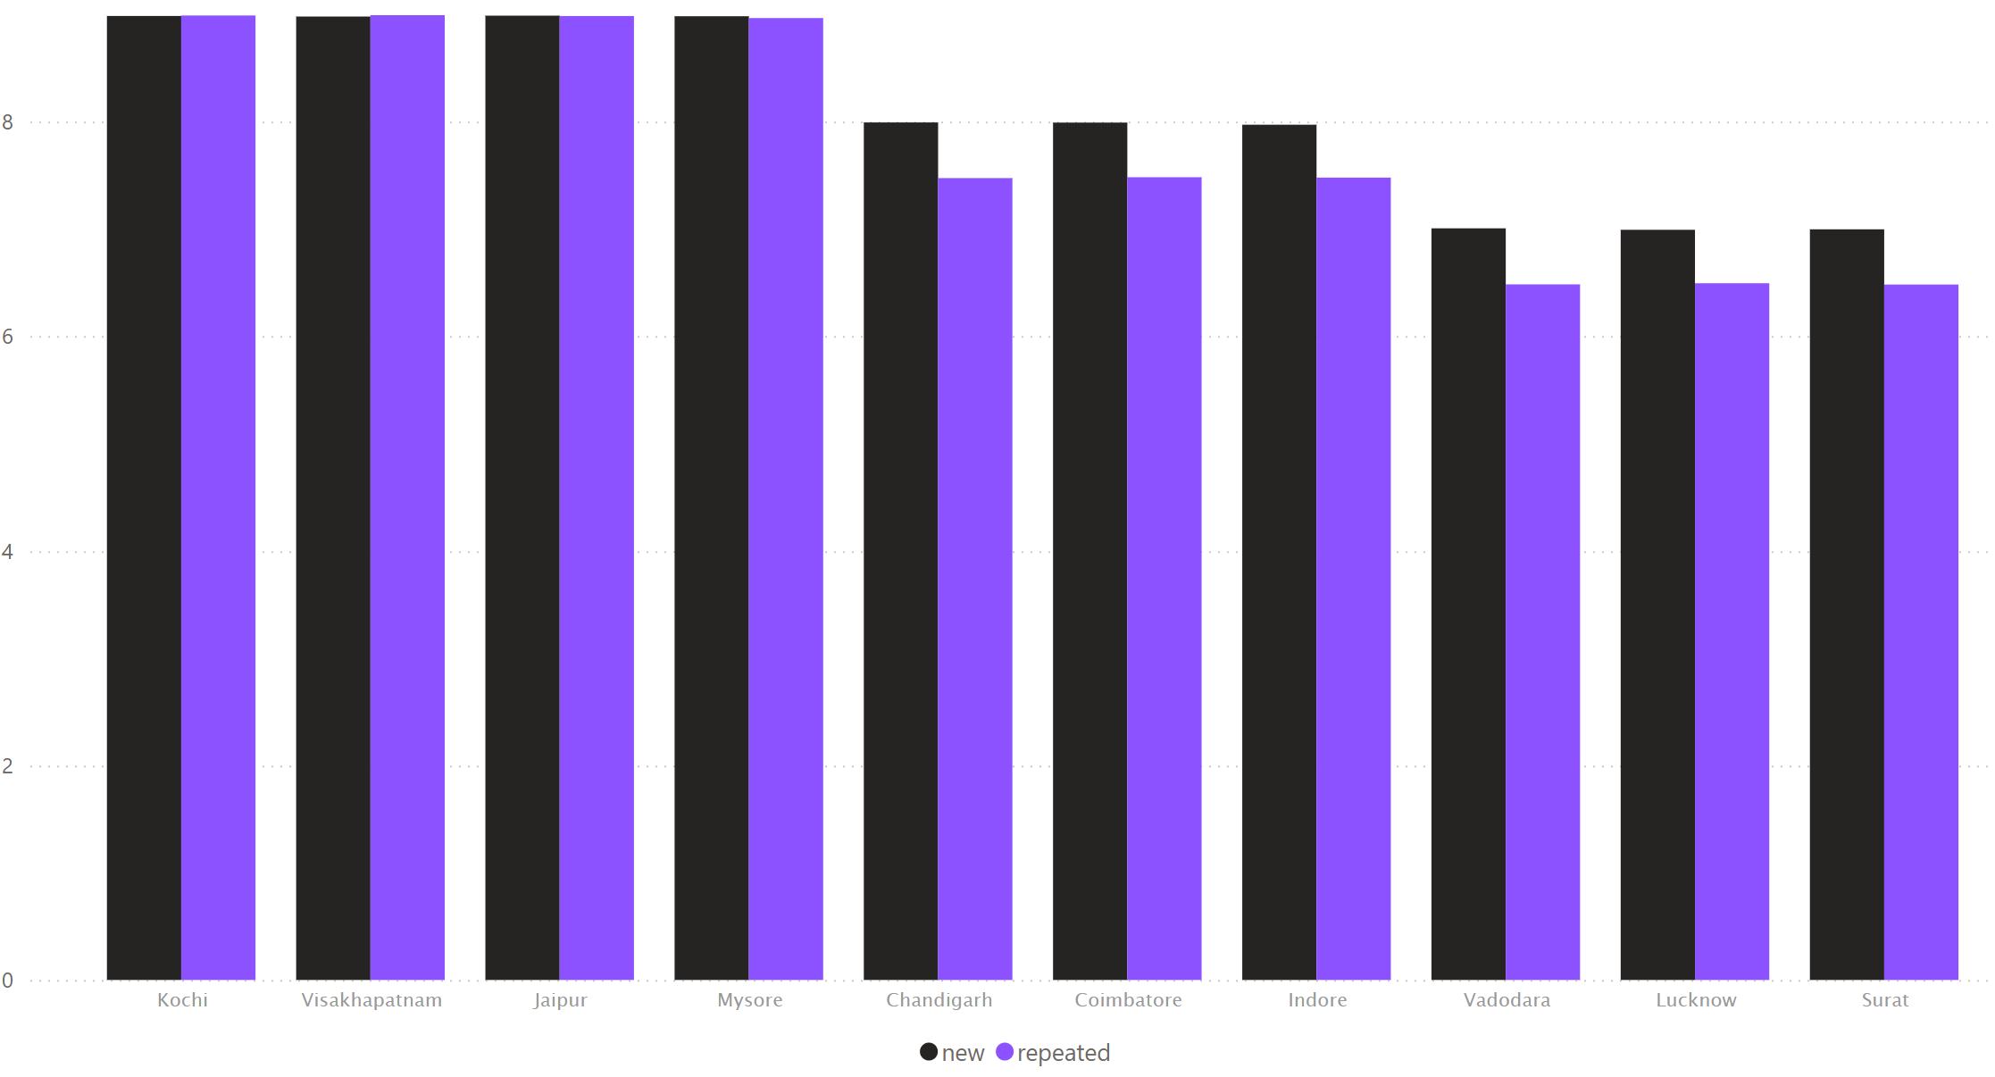
- New Customers Rate Drivers Higher Than Repeat Customers Everywhere
- Kochi and Visakhapatnam achieved the highest driver ratings across both new and repeat customers, reflecting consistently strong customer experiences.
- Jaipur demonstrates strong overall performance, combining high customer satisfaction with high trip volumes and the highest average fare per trip among all cities analyzed.
- Lucknow and Surat show comparatively lower driver ratings despite handling significant trip volumes, indicating possible customer experience issues that should be investigated further.

Weekend vs. Weekday Trip Demand by City

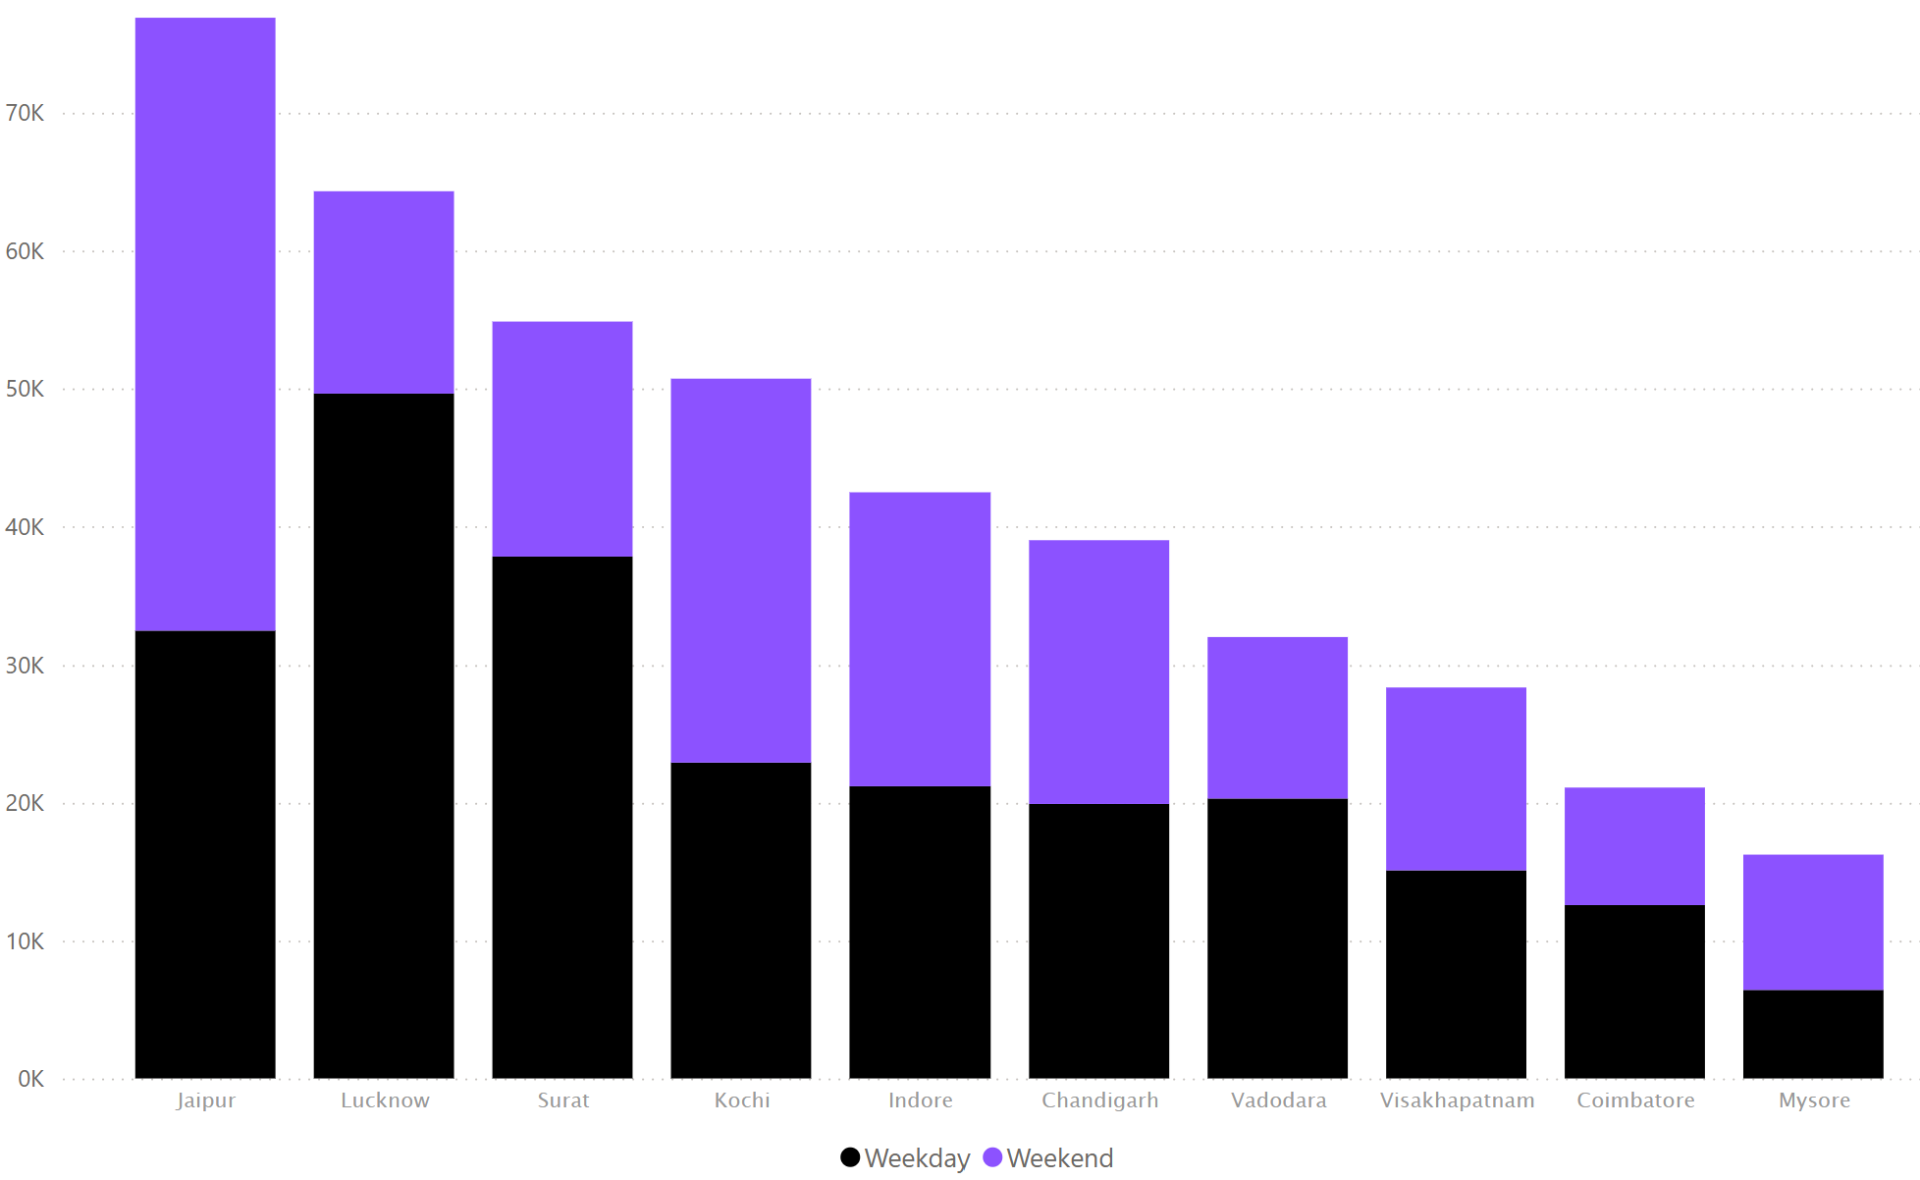
- Jaipur records substantially higher trip volumes on weekends than weekdays, indicating that demand peaks during weekends and may be influenced by leisure or recreational travel.
- Jaipur stands out as the only city where weekend demand significantly surpasses weekday demand, making it a unique demand market compared to all other cities.
- Lucknow and Surat exhibits a strong weekday-centric demand pattern, with weekday trips significantly exceeding weekend trips, indicating dependence on regular travel demand throughout the workweek.

- Weekend-Oriented Cities
  - Jaipur
  - Kochi
  - Indore
  - Chandigarh
- Weekday-Oriented Cities
  - Lucknow
  - Surat
  - Vadodara

Repeat Passenger Frequency and City Contribution Analysis
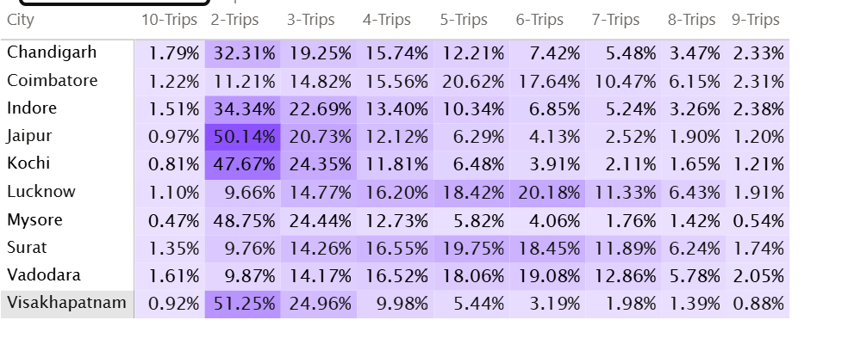

- Across most cities, repeat passengers are concentrated in the 2–3 trips per month segment, indicating that moderate-frequency riders form the largest share of the repeat customer base.
- High-frequency repeat passengers (9-10 trips per month) represent a very small portion of the customer base across all cities, generally accounting for less than 3% of repeat riders.
- Nearly half of repeat passengers in Jaipur, Visakhapatnam, Mysore, and Kochi make only two trips per month, suggesting a strong concentration of low-frequency repeat riders in these markets.
- Compared to other cities, Lucknow exhibits a stronger presence of medium-frequency repeat riders, with more than one-fifth of repeat customers completing six trips per month.
- Surat's repeat passenger base is more evenly distributed across trip-frequency segments, suggesting a balanced mix of occasional and frequent riders.
- Chandigarh is a hybrid market, with strong 2-trip segment (32%) and still meaningful 4–6 trip segments

- Low-Frequency Cities (2-3 Trips)
  - Jaipur
  - Kochi
  - Mysore
  - Visakhapatnam
  - Indore
- Medium-Frequency Cities (5-6 Trips)
  - Lucknow
  - Surat
  - Vadodara
  - Coimbatore
- This suggests fundamentally different customer usage behaviour.

Monthly Target Achievement Analysis for Key Metrics

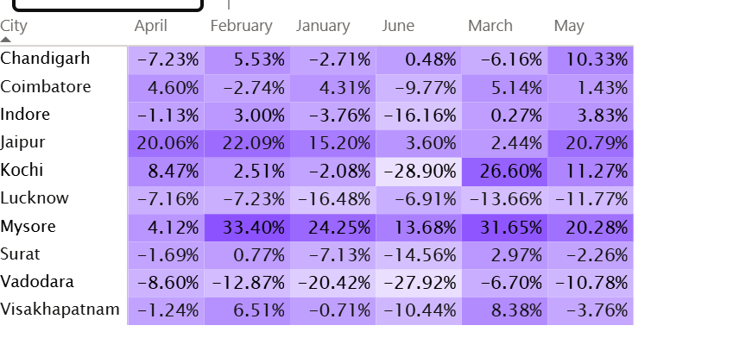
- Vadodara and Lucknow consistently underperformed against trip targets throughout the six-month period, failing to achieve monthly targets in any month.
- Jaipur demonstrated the strongest and most consistent target achievement performance, exceeding monthly trip targets throughout the entire period and outperforming targets by more than 20% in several months.
- Mysore consistently exceeded targets and delivered the highest target overachievement in multiple months, outperforming even Jaipur during February and March.
- Cities that consistently miss targets should be investigated to identify operational, demand, or capacity constraints before implementing corrective measures.
- Consistent overachievement in cities such as Jaipur and Mysore suggests that current target-setting mechanisms may require recalibration to better reflect actual demand levels.
- June emerged as the weakest-performing month overall, with only three cities exceeding their trip targets.

Highest and Lowest Repeat Passenger Rate (RPR%) by City and Month

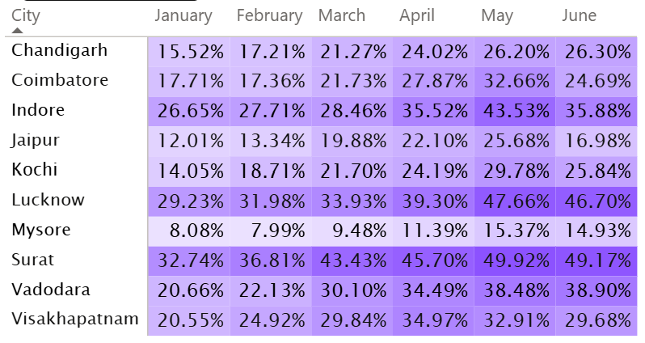
- Surat and Lucknow combine strong customer retention with high trip volumes, shorter trip distances, and lower average fares, indicating a strong dependence on recurring local travel demand.
- Despite having comparatively lower driver ratings, Surat and Lucknow maintain the highest repeat passenger rates, suggesting that factors other than driver experience may be playing a significant role in customer retention.
- Despite strong operational performance and high customer ratings and excellent target achievements, Mysore records the lowest repeat passenger rates, indicating potential challenges in converting customers into repeat riders.
- Customer retention improved consistently across nearly all cities during the six-month period, suggesting successful customer engagement and retention efforts.

